**COP 4808-001: Full-Stack Web Development**

**Lab2**

**Due: Feb 2 at 11:59pm**

GitHub Username: ccabreragarc

GitHub Repo URL: <https://github.com/ccabreragarc/Lab2>

#### **Step 0: Create a New React Project Using Vite**

* Open the Terminal and navigate to your Github repository.
* In your GitHub repository, create a new Vite React project called samosa-selector.

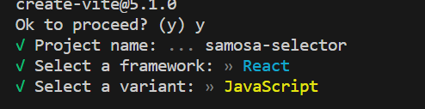

* Open your project in Visual Studio Code
* Replace the provided starter code in App.jsx

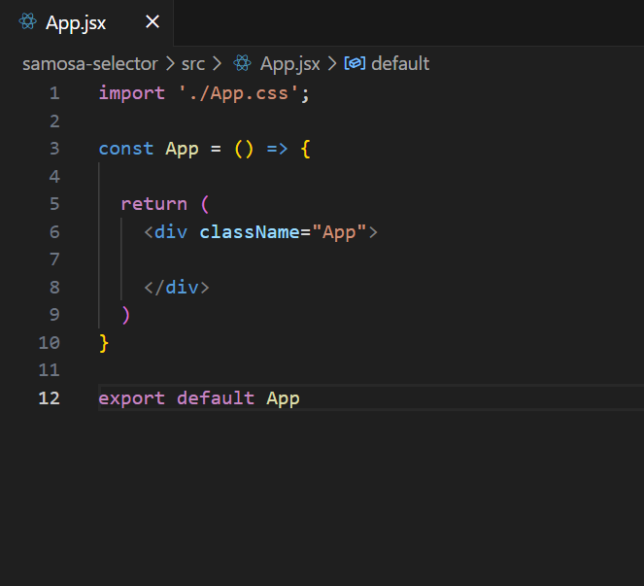

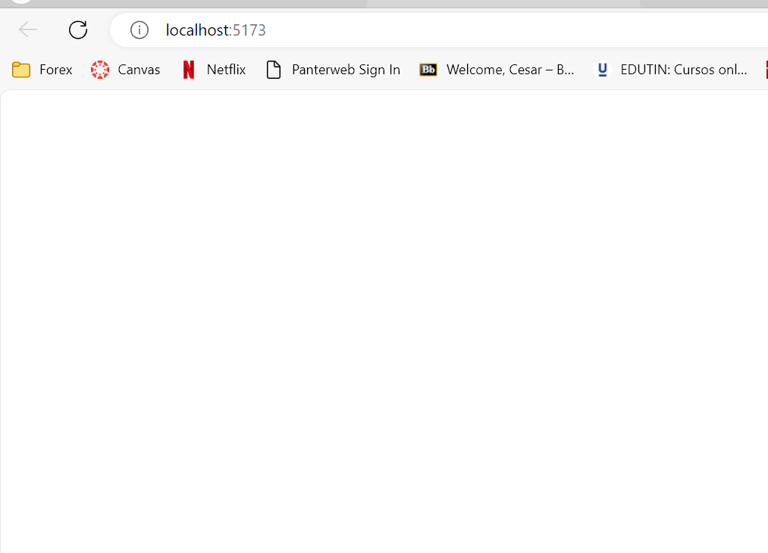

#### **Step 1: Create the User Interface**

In this step, we will create a basic user interface for the game.

In App.jsx:

* Create the following nested elements in the <div className="App>":
  + A <div> with the className="header" with the following nested elements:
    - An <h1> with the title "Samosa Selector"
    - An <h2> with the text "Count:"
    - An <img> with the className="samosa" and src set to an image of a samosa (use one from the internet for now).

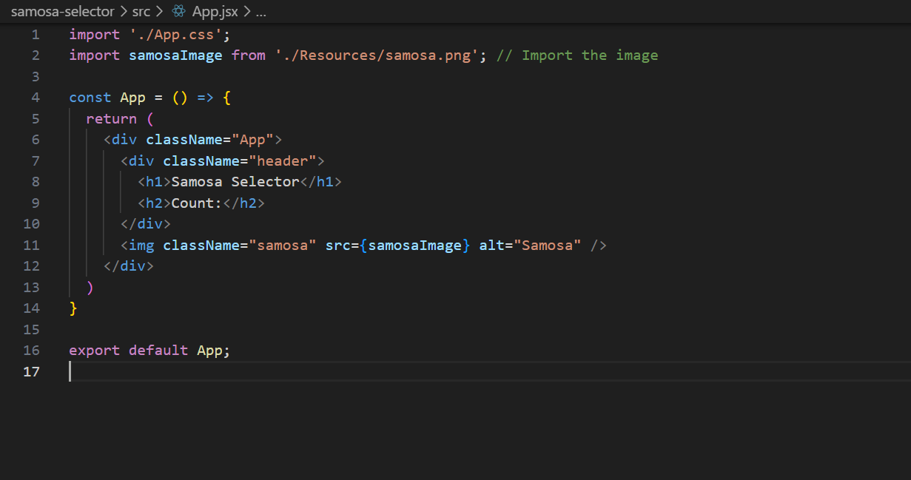

Add some style to the interface using CSS:

* Create a style rule in App.css for .samosa with the following rules:
  + Set the height of the image to 15em
  + Set the padding of the image to 1.5em
  + Set the margin to 0 auto
  + Set the text-align to center

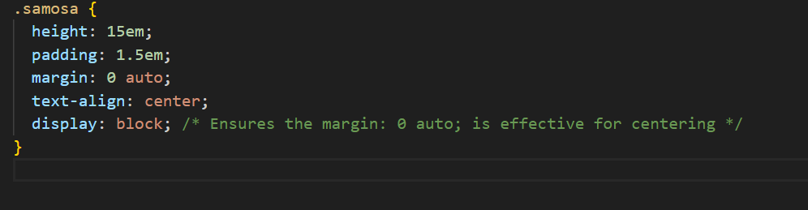

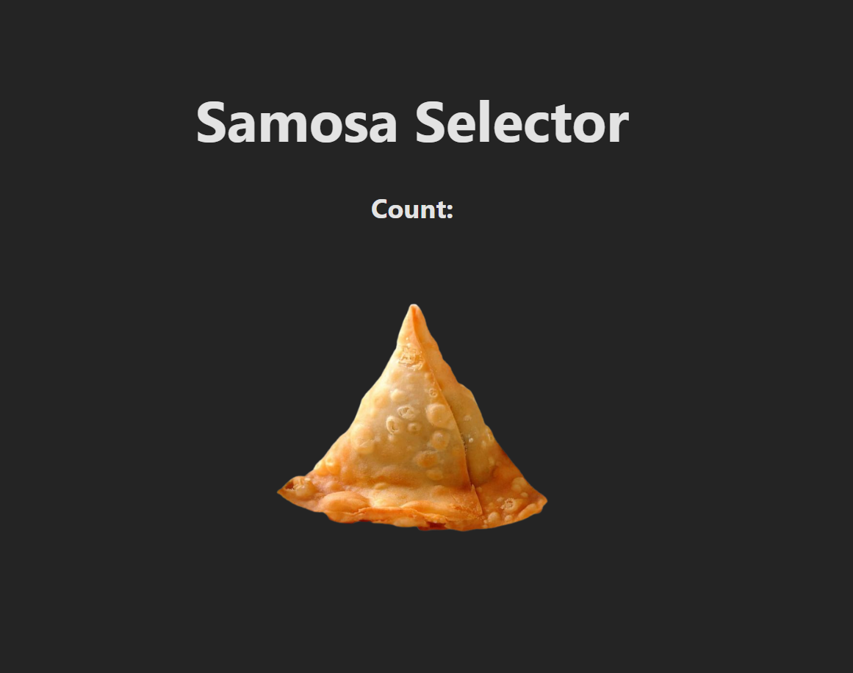

#### **Step 2: Add a Counter**

In App.jsx:

* Check that you have imported the useState hook from 'react'.
* Using the useState() hook, create a state variable called count with a value of 0. Using the useState() hook, create a state variable called multiplier with a value of 1.
* Define a function called updateCount() that sets the value of the state variable count to its current value plus multiplier when called.

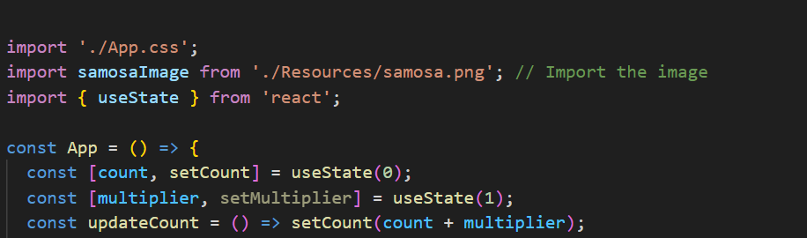

* Set the updateCount function as the onClick event handler for the <img> element displaying the samosa when it is clicked.
* In the <h2> tag, call the count state variable to display the number of clicks.



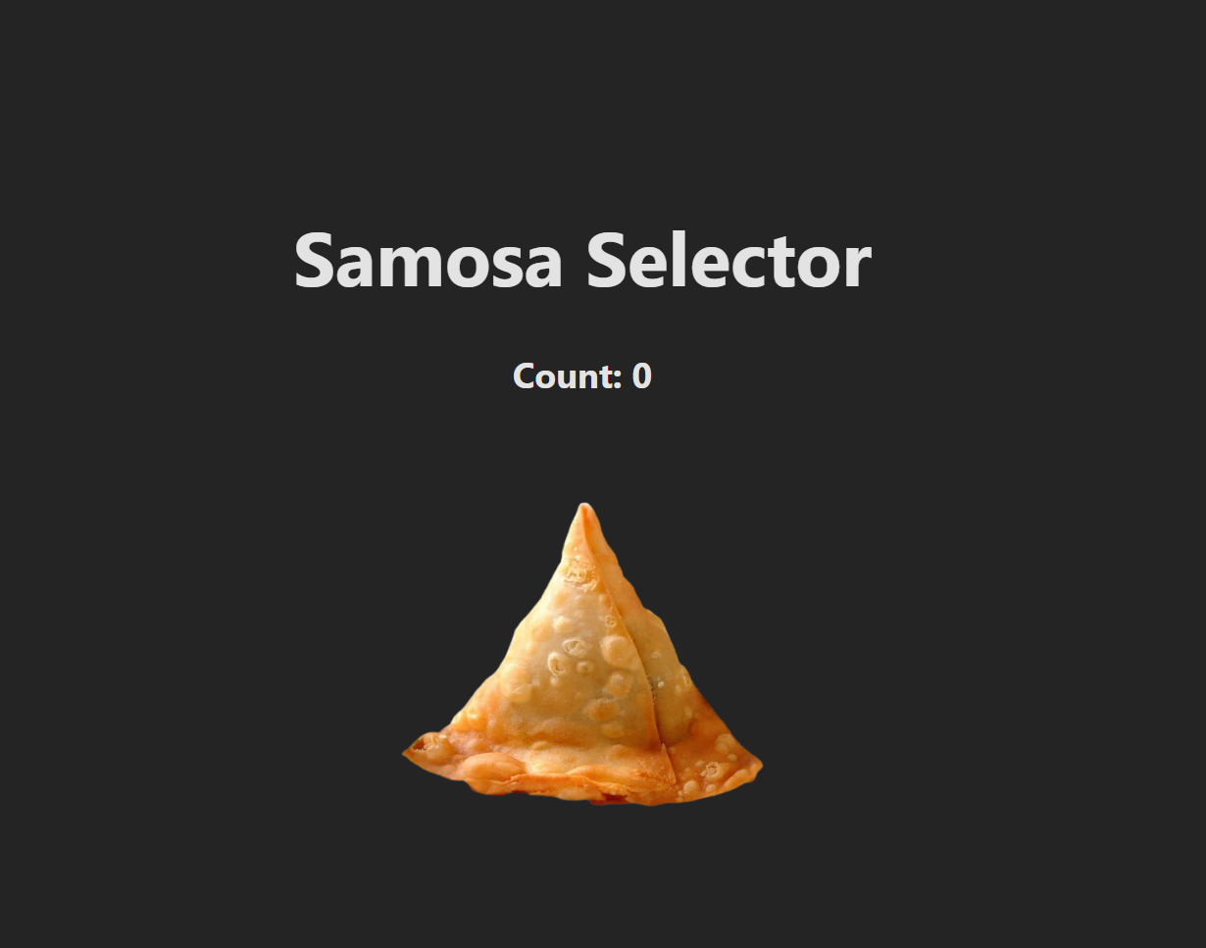

#### **Step 3: Add Upgrades**

In this step, we will add three upgrade options to the user interface.

|  |  |  |
| --- | --- | --- |
| **Name** | **Description** | **Cost** |
| Double Stuffed 👯‍♀️ | 2x per click | 10 samosas |
| Party Pack 🎉 | 5x per click | 100 samosas |
| Full Feast 👩🏽‍🍳 | 10x per click | 1000 samosas |

In the <div> with the class name App, add the following:

* A <div> with the className="container" with the following nested elements:
  + For each upgrade, create a <div> with the className="upgrade" that contains the following nested elements
    - An <h3> heading with the name of upgrade
    - An <p> with a description of the upgrade
    - A <button> with a label with cost of samosas needed to apply the upgrade

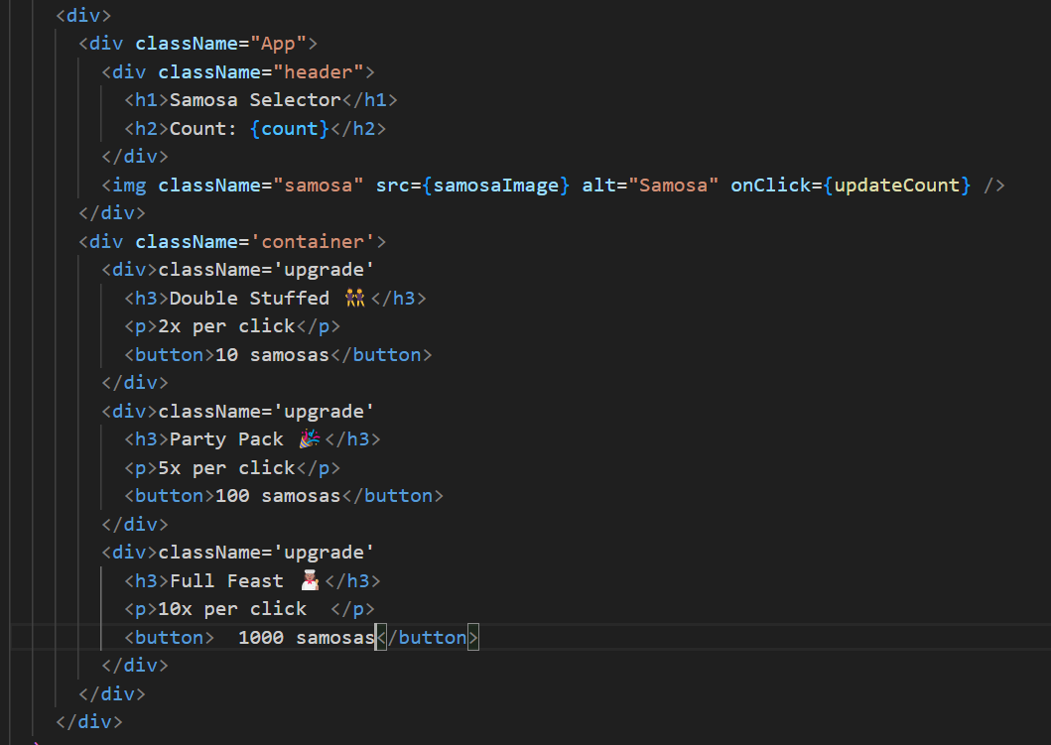

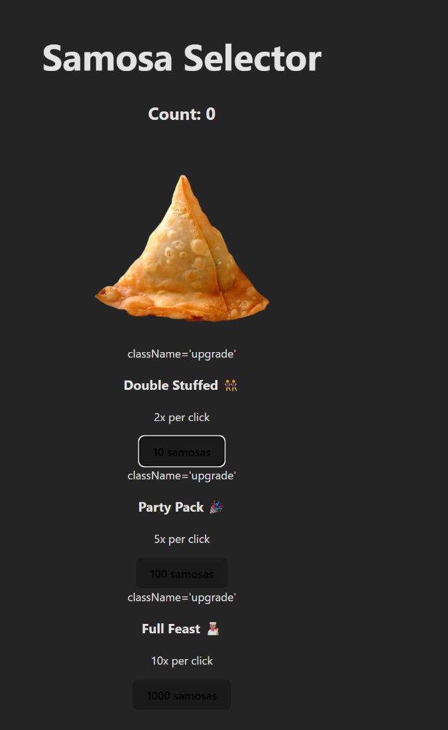

* Create a style rule for .container that sets the top margin to 50px and the display to flex.
* Create a style rule for .upgrade with the following rules:
  + Border should be 1px solid rgba(153, 153, 153, 0.497)
  + Padding should be 20px for the top and bottom and 10px for the left and right
  + The right margin should be 25px
  + Width should be 200px
  + Line height should be 0.5

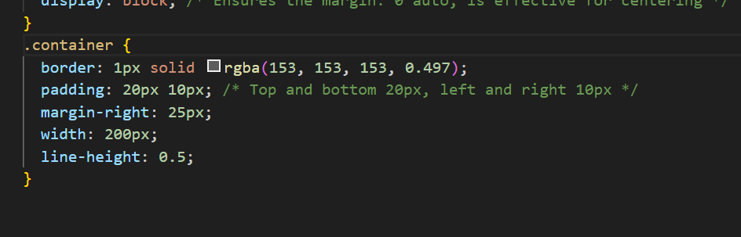

* Create a style rule for button with the following rules:
  + Border radius should be 8px
  + Border should be 1px solid transparent
  + Padding should be 0.3em for the top and bottom and 1em for the left and right
  + Font size should be 1em
  + Font weight should be 500
  + Font family should be inherit
  + Background color should be #1a1a1a
  + Color should be rgba(255, 255, 255, 0.87)
  + Set the cursor to pointer
  + The top margin should be 10px

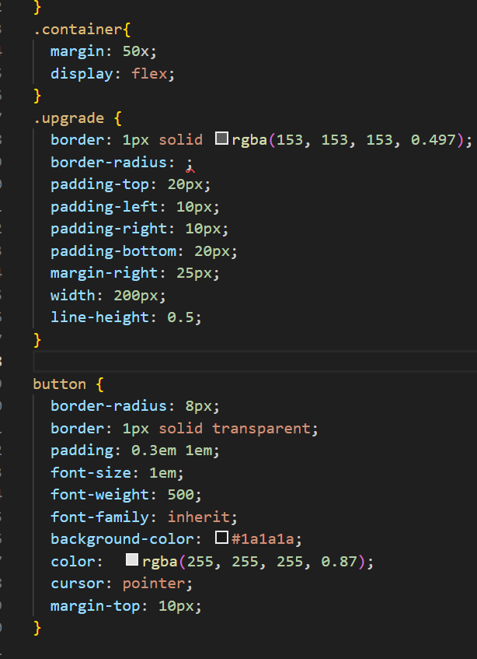

#### **Step 4: Handle Upgrades**

In this step, we will add event handlers to the button of each upgrade. If the user has enough samosas, the upgrade changes the threshold of the multiplier state variable.

* Define a function called buyDoubleStuffed() that sets the value of the state variable multiplier to two times its current value if the current number of counts is greater than or equal to 10.
* Set buyDoubleStuffed() as the onClick event handler for the <button> labeled 10 samosas.
* Define a function called buyPartyPack() that sets the value of the state variable multiplier to five times its current value if the current value of count is greater than or equal to 100.
* Set buyPartyPack() as the onClick event handler for the <button> labeled 100 samosas.
* Define a function called buyFullFeast() that sets the value of the state variable multiplier to ten times its current value if the current value of count is greater than or equal to 1000.

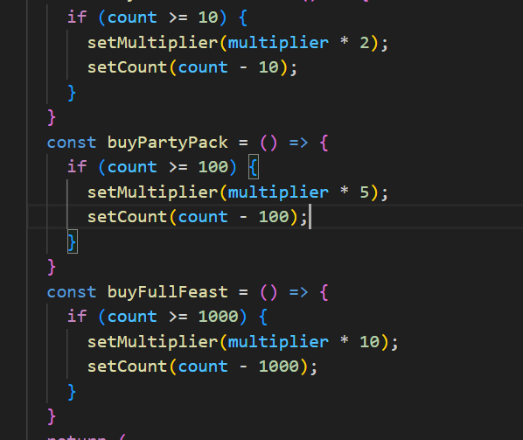



#### **Step 5: Reduce Samosa Count After Upgrade Purchase**

In this step, we will update each of the event handling functions so that the user loses samosas from their total count for the upgrades they purchase.

* Using setCount(), reduce the count state variable by 10 when the user purchases a **Double Stuffed** upgrade.
* Using setCount(), reduce the count state variable by 100 when the user purchases a **Party Park** upgrade.
* Using setCount(), reduce the count state variable by 1000 when the user purchases a **Full Feast** upgrade.

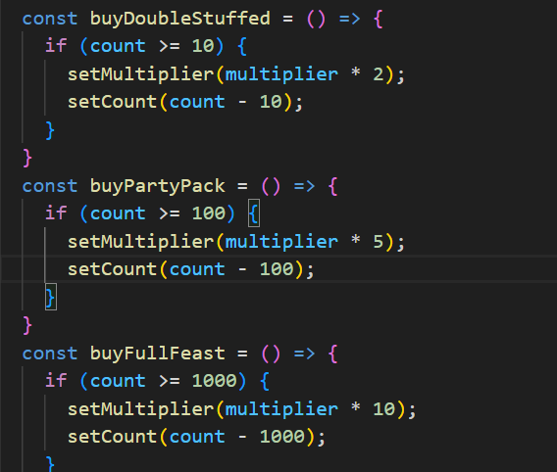

#### Step 6: Change Size of Samosa on Hover and Click

In this step, we will add CSS to transform the samosa to grow when hovered and shrink when clicked to create a "pulse" effect.

* Create a CSS rule for the .samosa:hover that sets the cursor to pointer and the transform property to scale(1.1).
* Create a CSS rule for the .samosa:active that sets the transform property to scale(0.95).

